Figure 1. The Bangunan Sultan Abdul Samad
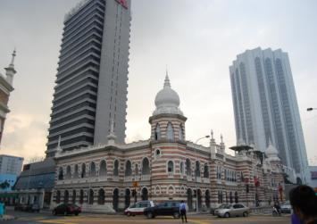

Figure 2. Anglo-Oriental Building
Source: CHEN (1998), p101
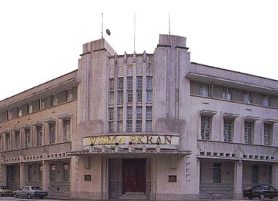

Figure 3. Shophouses, Jalan Nogor in Penang
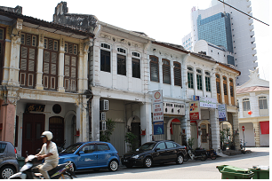

Figure 4. Indio-Malay Style Bungalow, Jalan York in Penang
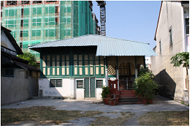

Figure 5. Teh Bunga’s House,
Strait Eclectic Style
Lorong Hutton in Penang
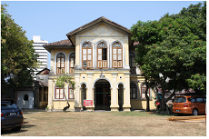

Figure 6. Housing Stock of Malaysia
Source: CEIC, 2007.9
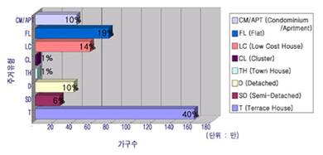

Figure 7. Town Plan of Setia Alam, KL
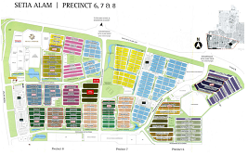

Figure 8. Cluster Housing in Cheras, 1976
Source: www.arkitektenggara.com
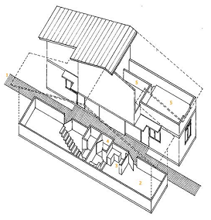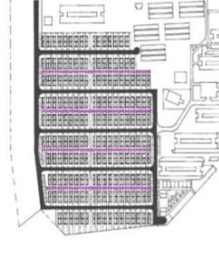

Figure 9, Perspective Images of Cluster House
Source: Advertisement Material of Setia Alam, 2008
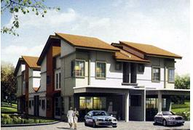

Figure 10. Apartment Putra Ria, Jalan Bangsar, KL, Built at 1996, Managed by DBKL
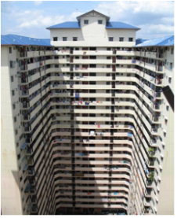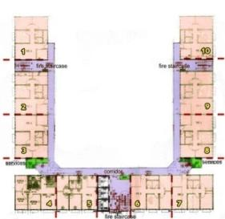

Figure 11. (Top Left) Villa Pavilion
(Top Right) Airwell in Corridor
Designed by Zaini Mufti Architect, 2007
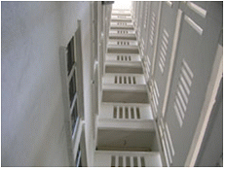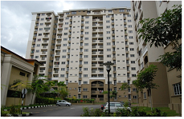

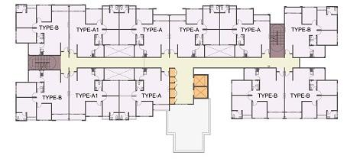

Figure12. High-End Condominium Projects Under Construction in Prime Area Around the Petronas Twin Tower, KL


