Table 1. Chronology of Malaysia
1786 | A British settlement is established on Penang by Francis Light
1791 | The East India Company(EIC) and Sultan Abdullah of Kedah sign an agreement on the cession of Penang
1818 | Melaka is returned to the Dutch
1819 | Raffles established a free port on Singapore island
1824 | Raffles established a free port on Singapore island
1825 | Formation of the Straits Settlements(Penang, Singapore and Meleka)
1840 | The importance of tin increases, bringing an influx of Chinese tin miners to the western coast
1858 | The Strait Settlement are passed from the control of EIC to the British government
1880 | Kuala Lumpur becomes the state capital of Selengor
1880s | Large-scale expansion of the mining in Perak
1885 | The first railway line, between Taiping and Port Wels, is opened
1890s | The first rubber estated are planned in Malay Peninsula
1891~5 | Rising by Malay chiefs in Pehang against British rule
1895 | Johor's constitution, the first for a Malay estate, is adopted by the State Council
1896 | Selangar, Perak, Negri Sembilan and Pahang are united as the Federated Malay States(FMS) with a Resident General in Kuala Lumpur, the capital and a High Commissioner in Singapore
1909 | The Federated Council is established as a legislative body for the Federated Malay States  The rail link from Pahang to Johor Bahru is completed, with ferry service to Singapore
1914~18 | World War I.
1923 | The Labor Code makes it compulsory for estates to provide schools for the children of their workers
1941~45 | Japanese invasion of the Malay Peninsula
1945 | British reoccupy Malaya
1957 | The Federation of Malaya is granted independence from the British government
1965 | Singapore leaves Malaysia and becomes an independent nation

Table 2. Middle and Low Density Hosing Typology
(Setia Alam and Setia Eco-Park Town, 2008)
typology | Detached House  (Bungalow) | Terrace House  (Link House) | Semi-Detached  Housing
plot  plan | 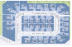 | 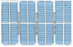 | 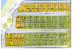
ground  plan | 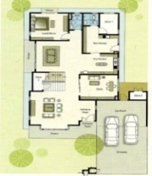 | 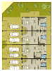 | 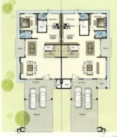
general  views | 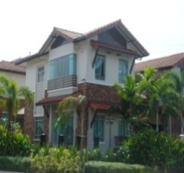  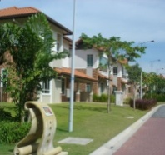  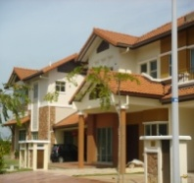 | 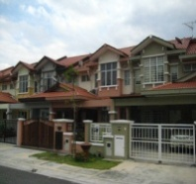  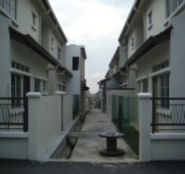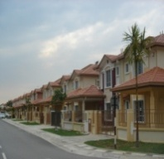 | 

